Alexander Cannell

03/09/12

Professor Roberson

Chapter 9

**Project 9-1:**

1.

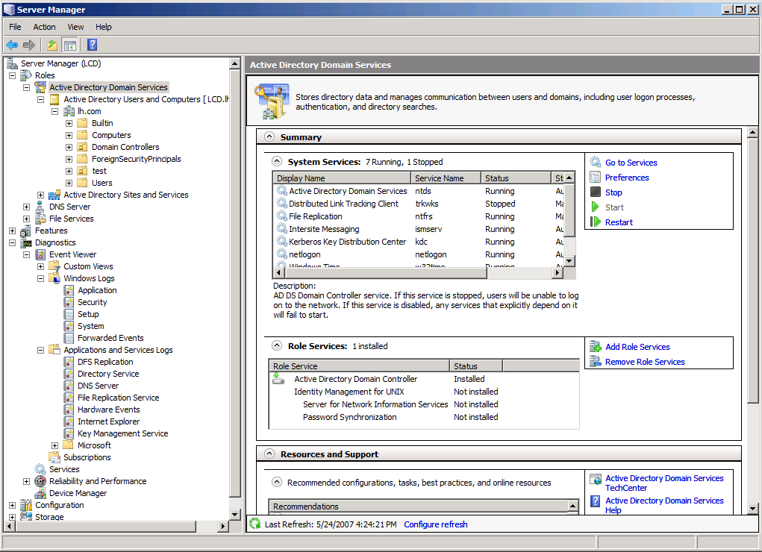

This shows the Server Manager, and the active directory domain services.

2.

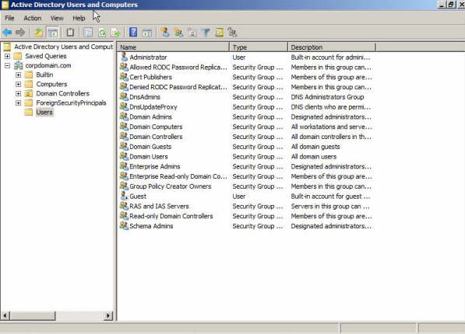

The Active Directory Users and Computers, and the users list.

3.

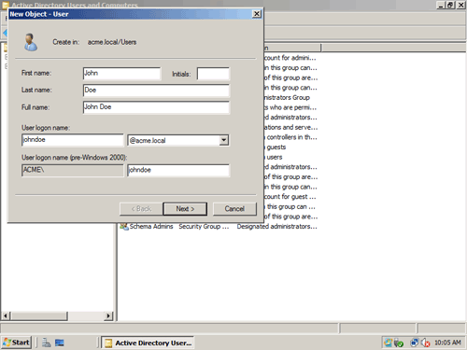

Making a new user in the active directory.

**Project 9-2:**

Go through the same first steps through the active directory.

1.



Now we create a new user group.

2.



Properties of the group.

What I did is to make a new user name, password, and active directory. I also learned how to make a new group, manage permissions, and utilize the properties.

What I learned how to create a new user and group in windows server.

How this applies to a network professional is that you might need to manage their create a user and new group windows server 8.

**Project 9-3:/ Project 9-4:**

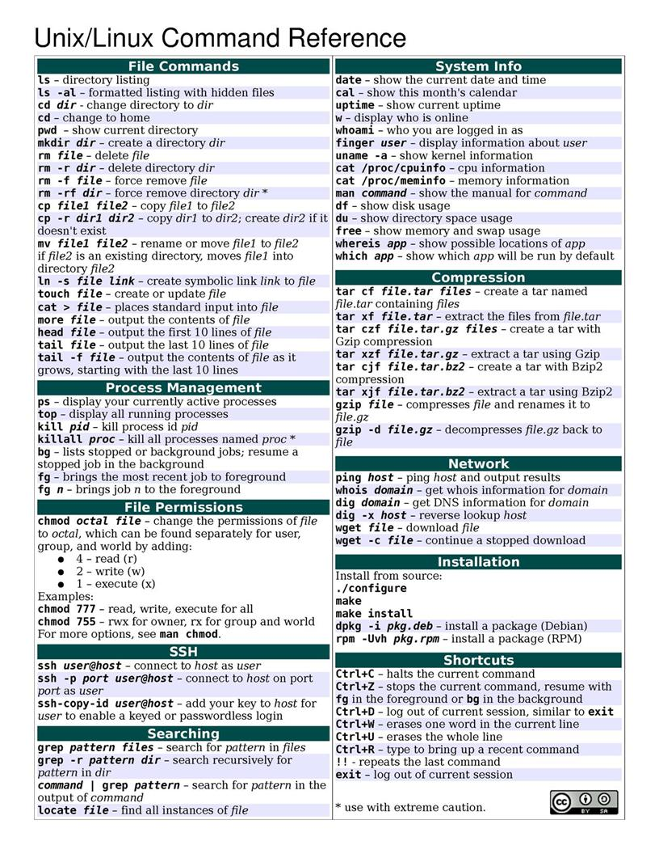

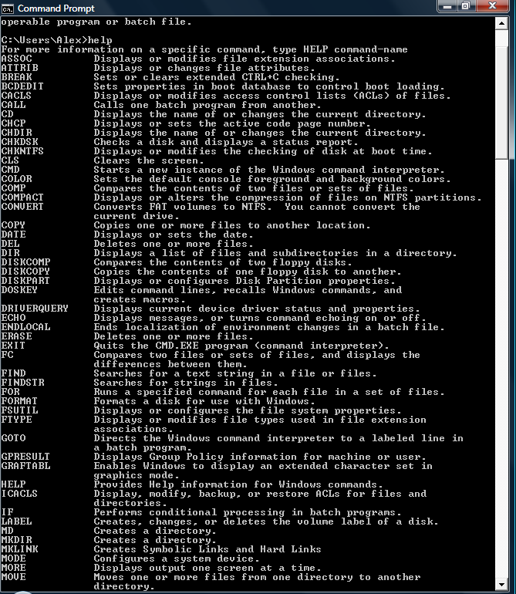

What I did is used command prompt special commands in Linux to make a new user name, password, and active directory. I also learned how to make a new group, manage permissions, and utilize the properties.

What I learned is how to create a new user and group in Linux command prompt. Linux can be utilized like a windows server.

How it applies to a networking professional, most networking professionals will use this to add a server and groups, and they might be using a Linux operating system for cost efficiency.